- 复制会议链接在网页中打开。

https://teams.microsoft.com/dl/launcher/launcher.html?url=%2F_%23%2Fl%2Fmeetup-join%2F19%3AEqdjqgf7I-0NqFAJnv1lSNBd7lr_dMV1GUMSlzaDA1A1%40thread.tacv2%2F1633965773554%3Fcontext%3D%257b%2522Tid%2522%253a%25225d4d7abe-8d19-41b7-9d8c-1a5b2af5dc17%2522%252c%2522Oid%2522%253a%25226abbcc2d-080d-490c-bce5-8bc15e3afcd3%2522%257d%26anon%3Dtrue&type=meetup-join&deeplinkId=a9e96ef0-4fab-4824-a021-c578a3e5b908&directDl=true&msLaunch=true&enableMobilePage=true&suppressPrompt=true

- 单击“在浏览器上继续”

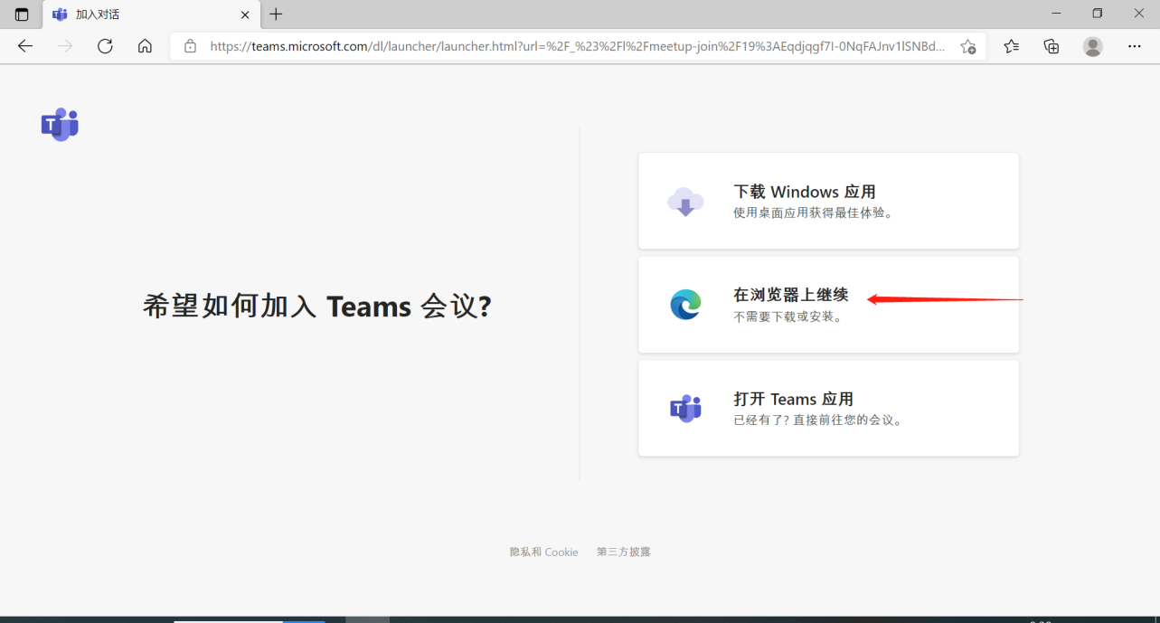

- 单击“立即加入”
