Microsoft Teams 进入会议操作指南

一、复制会议链接在网页中打开。

https://teams.microsoft.com/l/meetup-join/19%3aXy5QIiBvX2ODXLJEw_ceZ8ZrL56a9925rcBbwS_PcI41%40thread.tacv2/1668366210993?context=%7b%22Tid%22%3a%225d4d7abe-8d19-41b7-9d8c-1a5b2af5dc17%22%2c%22Oid%22%3a%226abbcc2d-080d-490c-bce5-8bc15e3afcd3%22%7d

二、单击“在浏览器上继续”
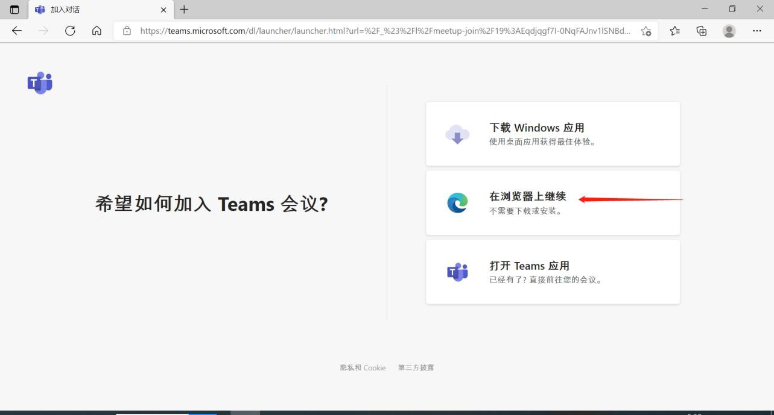

三、单击“立即加入”
